PROJECT REPORT
NOTEPAD WITH UNDO (Qt GUI & CUSTOM STACK)

By:
Ali Murad
Muhammad Jalal

Lab Engineer:
Mr. Safder Ali
Instructor:
Dr. Adnan idris

Course: Data Structures & Algorithms (DSA) Lab
Technologies: C++, Qt Framework, Template Classes

Department of Computer Science
Bachelors in Artificial Intelligence (AI)
NUST Balochistan Campus
Dec 2025
1. ABSTRACT
This project implements a text editing application featuring robust Undo/Redo capabilities. Unlike standard text editors that rely on pre-built libraries, this project implements a Custom Stack Data Structure using Template-based Linked Lists. The interface is built using the Qt Framework, designed with a minimalist aesthetic to ensure the focus remains on the underlying algorithmic logic rather than graphical overhead.
2. PROJECT OBJECTIVES
- Algorithmic Mastery: To replace standard STL containers (std::stack) with a raw, self-managed Linked List Stack.
- GUI Integration: To bridge the gap between backend C++ logic and frontend Qt Widgets.
- Memory Management: To implement strict LIFO (Last-In-First-Out) logic for history tracking without memory leaks.
3. CHALLENGES & DEVELOPMENT HURDLES
"Why Minimalist? Why Custom Data Structures?"
During the development phase, we encountered significant challenges by choosing to implement everything from scratch. These hurdles defined our final design choices:
3.1 The "Heavy Code" Dilemma (Linked Lists vs. Arrays)
We chose a Linked List for our Stack instead of a dynamic array.
- The Challenge: Writing a Templated Linked List from scratch made the code significantly "heavier" and more complex. Managing pointers (Node* next, Node* top) introduced risks of Segmentation Faults and memory leaks that do not exist with simple arrays.
- Impact on Readability: The raw pointer logic made the code harder to read for team members initially.
- The Solution: We adopted Outline Programming (splitting .h and .cpp files) to hide this complexity. The GUI code interacts only with clean function calls (push, pop), keeping the "ugly" pointer logic isolated in the backend.
3.2 Qt GUI Integration Complexity
Connecting a raw C++ Pointer-based structure to Qt’s Slot/Signal mechanism was difficult.
- The Challenge: Passing data from our custom Stack<Command> to the QTextEdit widget required careful type conversion.
- Decision: We opted for a Minimalist GUI. We avoided complex toolbars and ribbons. This ensures that when the user clicks "Undo," the presentation demonstrates the Stack Algorithm, not the graphical rendering.
3. SYSTEM ARCHITECTURE
We adopted a 3-Layer Modular Architecture to ensure strict separation between the Visual Interface (GUI) and the Core Algorithms (DSA).
- 1. Interface Layer (Qt GUI / main.cpp)
  - Role: The "Front-End." Captures clicks and renders the text.
  - Logic: Zero processing. It strictly passes signals to the backend.
- 2. Logic Layer (Notepad.cpp)
  - Role: The "Controller." Bridges the gap between Qt strings and C++ logic.
  - Task: Converts user actions into Command objects and executes the Inverse Logic for Undo.
- 3. Data Structure Layer (SimpleStack.h)
  - Role: The "Memory Manager." A raw C++ template class that manages dynamic memory on the Heap.
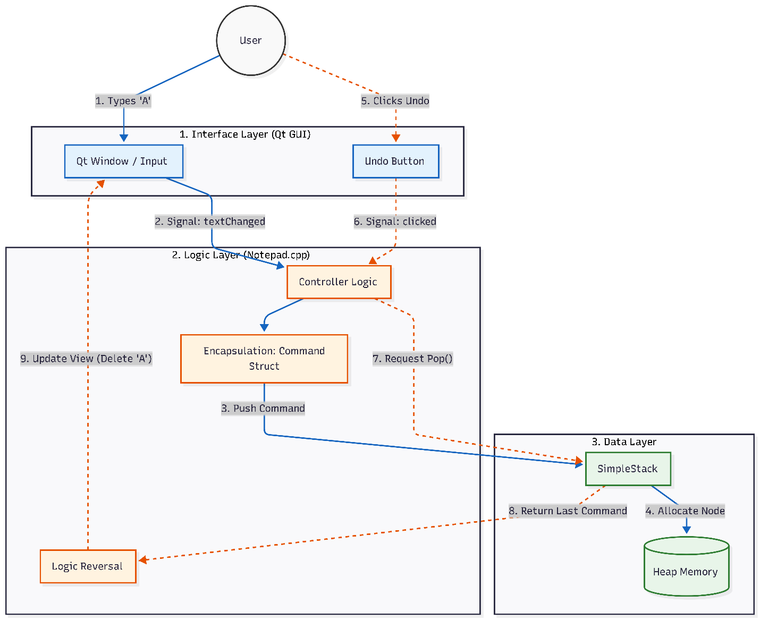

4. DATA STRUCTURES & ALGORITHMS
We rejected standard libraries (std::stack) in favor of a custom implementation to demonstrate memory mastery.
4.1 Custom Template Stack (SimpleStack<T>)
- Design: A Generic Class using C++ Templates.
- Benefit: Reusability. While currently storing Command objects, this stack can handle any data type without code duplication.
- Principle: Strictly enforces LIFO (Last-In, First-Out), the mathematical foundation of "Undo."

4.2 Singly Linked List (The Backend)
Instead of arrays, our Stack uses a Linked List.
- Why Linked List?
  - Infinite Growth: No fixed size limits. History grows dynamically until RAM is full.
  - Efficiency: Push/Pop are always O(1) (Constant Time), ensuring speed regardless of history size.
4.3 The Command Pattern
We encapsulate every keystroke into an Object.
- Structure: struct Command { Enum Action; String Text; Int Position; }
- Purpose: Preserves the context of an action, allowing the system to mathematically reverse it later.
4.4 Memory Management
- Heap Allocation: New nodes are created via new.
- Garbage Collection: A custom Destructor (~SimpleStack) automatically deletes all nodes upon exit, preventing memory leaks.
5. COMPLEXITY ANALYSIS
- Time Complexity:
  - Push/Pop (Undo): O(1) – Immediate, thanks to the Linked List.
  - Insert/Delete Text: O(N) – Dependent on the string length (standard C++ string behavior).
- Space Complexity:
  - O(N): Linear growth based on the number of actions stored in history.
6. USER INTERFACE DESIGN
We prioritized a Minimalist Aesthetic to keep the focus on the algorithm.
- Main View: A clean central text area with a dedicated "Status Bar" at the bottom.
- Visual Debugging: To prove the DSA concept during the demo, the Status Bar logs internal backend events (e.g., "Pushed [INSERT] to Stack"), making the invisible algorithm visible.
7. DATA FLOW (The Qt-Backend Pipeline)
- Event: User types "A" in the GUI.
- Signal: Qt captures the input and notifies the Controller.
- Encapsulation: Controller wraps "A" into a Command Struct.
- Allocation: SimpleStack allocates a new Node on the Heap.
- Undo Trigger: User clicks "Undo."
- Retrieval: Stack returns the last Command.
- Update: Controller reverses the logic (Delete "A") and updates the GUI.
8.Result
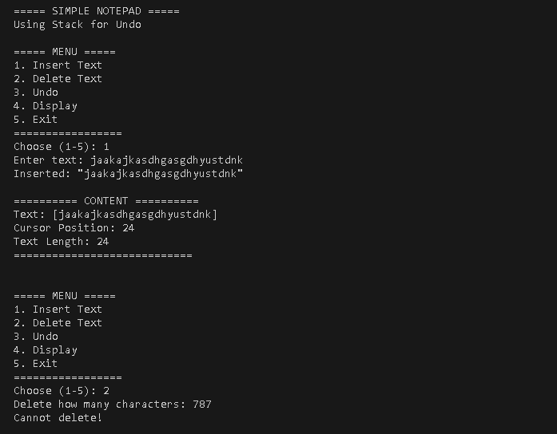

9. CONCLUSION
This project successfully bridges the gap between a modern Qt GUI and a raw C++ Data Structure. By implementing a Templated Linked List from scratch, we demonstrated:
- Deep Memory Control: Managing Pointers and Heap allocation manually.
- Algorithmic Efficiency: Achieving O(1) performance for history tracking.
- Software Architecture: Decoupling logic from the interface using Outline Programming.
The result is a lightweight, efficient editor that prioritizes logic over cosmetic bloat.

